**JCTE Client Development process**

Below is the process mentioned and the steps to be followed as part of every Sprint , for new Development /Maintenance Scripts.

**Branch Creation:**

In every sprint, Create a Separate Branch Based on User based on Develop Code base from VSTS

Copy the latest Code files from Visual Studio Local Repository after the above step, into the Squish Local Repository to start working in Squish IDE Includes (**Business Components, Data tables, Object Maps, from Support Libraries folder > Descriptive Object.py**)

Once Development is finished in Squish for a Particular Story , Pull and Merge the Latest Code from the Develop Branch into your New Story branch in your Local Visual Studio /Git Repo.

Integrate those necessary Code Files Changes in appropriate .Py files and only Test Data Rows in Excel from the **Squish Local Repo** to the **Local VSTS/GIT Repo** .

Run the **Bvt** Tests as per .run settings file (Mandatory) in Visual Studio Local and make sure it passed.

**Build Pipeline:**

Queue the Build Pipeline (**JCTE_Client_InSprint_Crew.Automation**) , Link mentioned below in the Azure DevOps VSTS and make sure it passed.

Please make sure **to link** the Appropriate Branch that you work to this Build Pipeline since Every Members uses their own branch.

<https://itsals.visualstudio.com/Crew/_apps/hub/ms.vss-ciworkflow.build-ci-hub?_a=edit-build-definition&id=2728>

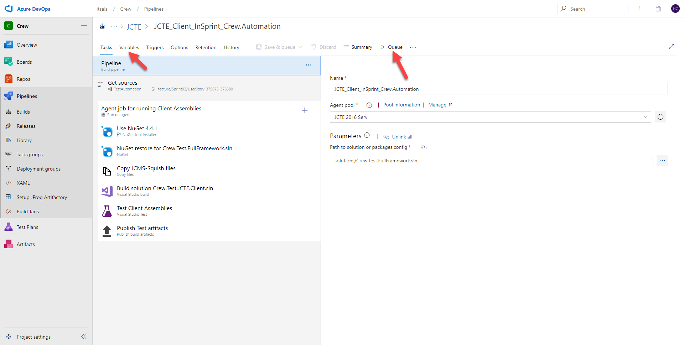

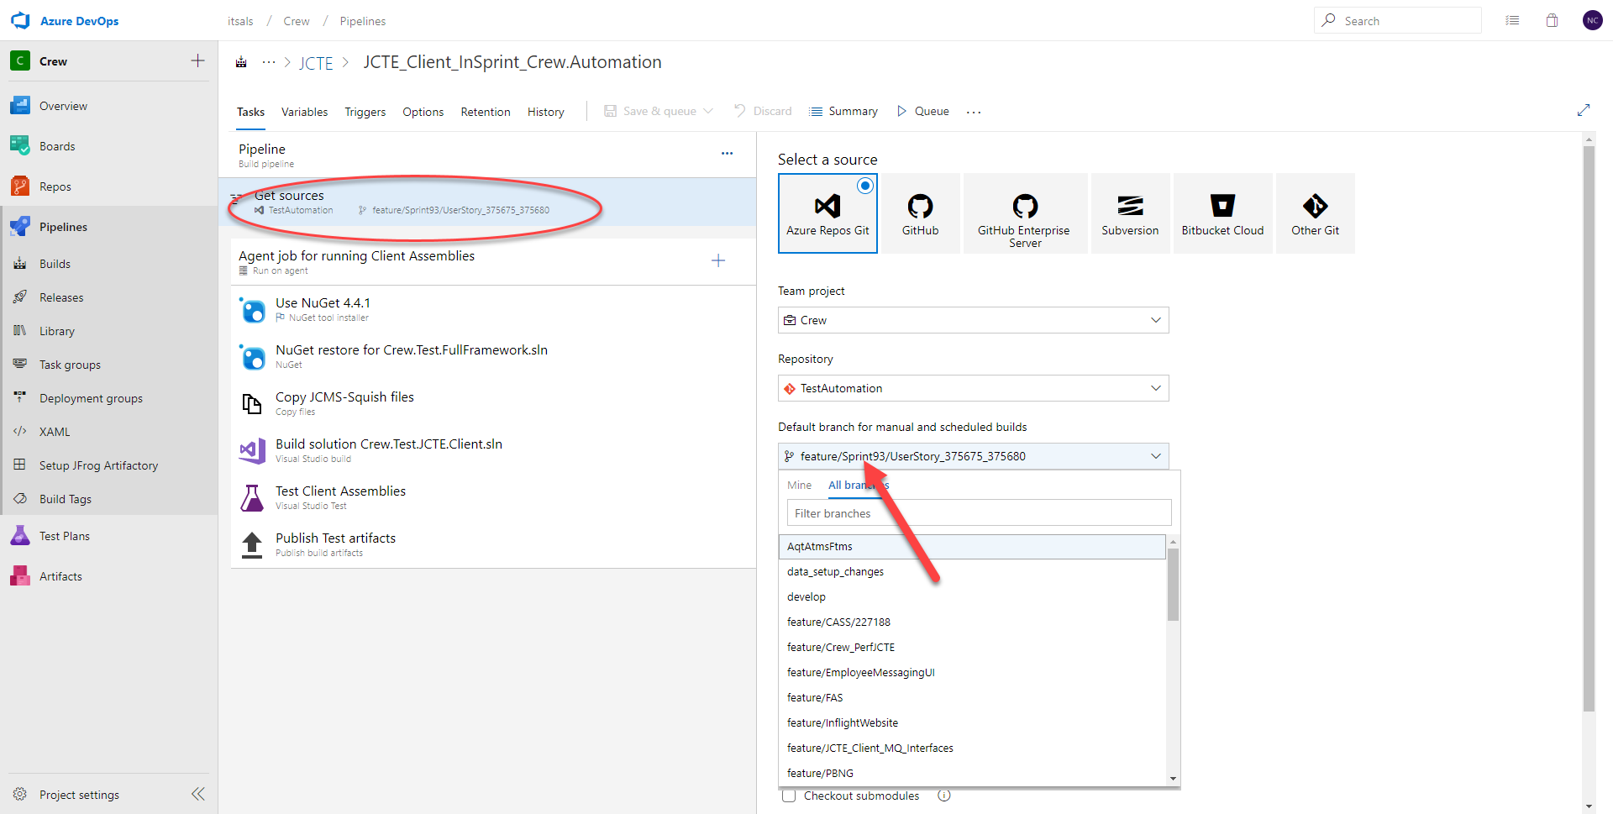

**Release Pipeline:**

Configure your Release Pipeline for In Sprint Development/Maintenance Tests in the **Variables** Menu ,by filling them with appropriate Values for **Functionality - Sub Functionality -User Group - Client Test Category - Component** for your Newly Designed Test cases in order to Pick only those Tests

Trigger the Release Pipeline**( Jcte_Client_InSprint _Testing** ) for those Tests as needed on a nightly job basis or Whichever u feel comfortable.

link mentioned below (<https://itsals.visualstudio.com/Crew/_releaseDefinition?definitionId=52&_a=definition-pipeline>) on the Agent Machines which are already configured and make sure those are passed.

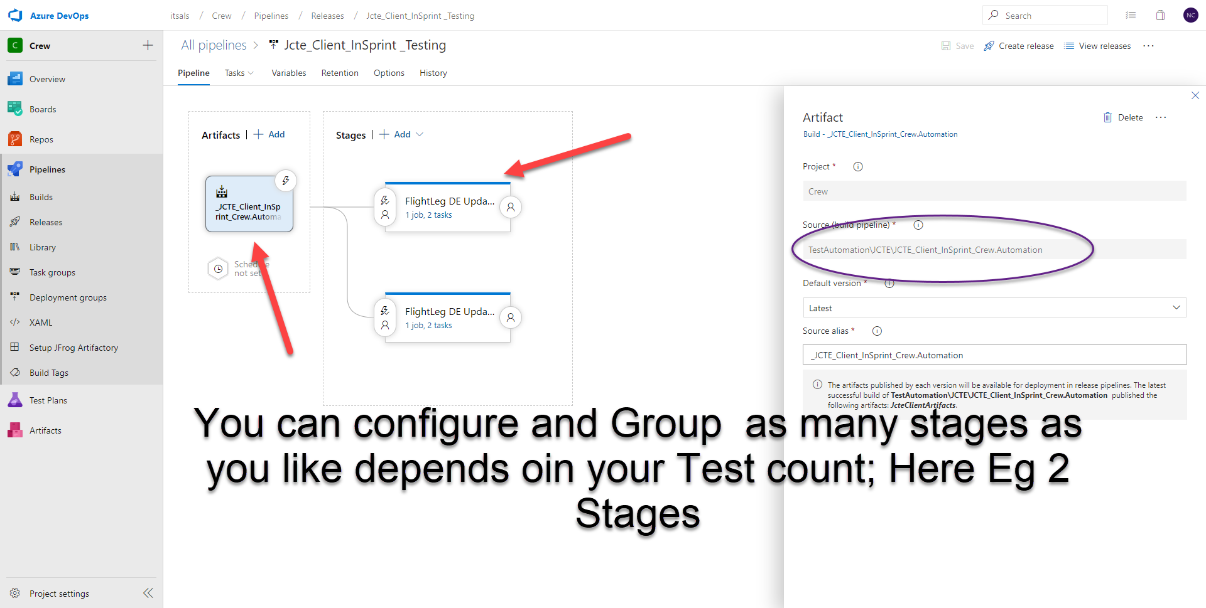

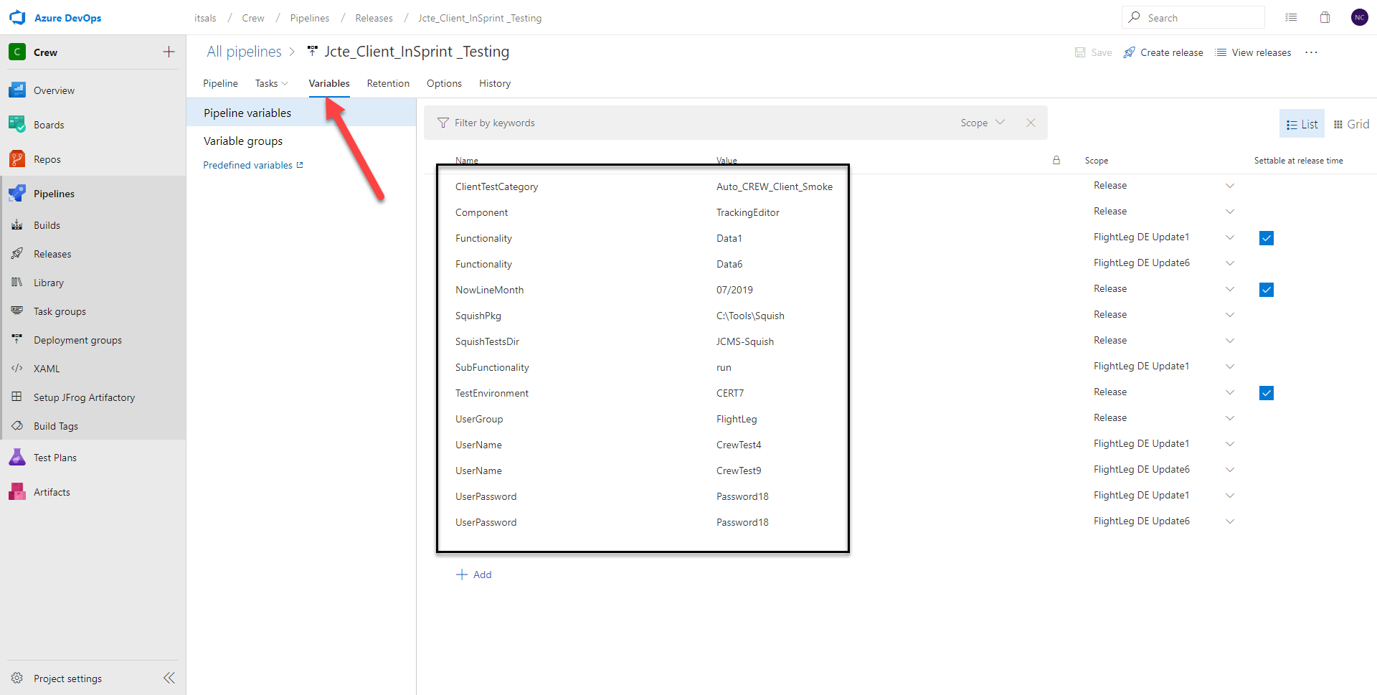

**Pull Request:**

Merge your branch with the Latest code from Develop branch if any changes are made on that Develop branch and Commit those to your branch If any.

Raise a Pull Request from your branch to the develop by mentioning the Story details in the Description.

Add Revivers to your code includes John Anthony ,and exclude you from the Reviewers List.

Follow Up with The Pull Request as needed by Replying to any of the Comments mentioned by JA if any applicable.

Finish the user Story

